BLADE CX MODS & UPGRADES

BROKEN FLYBAR MOUNT
Inner Shaft with Hub - breaks just below the flybar, $9.00
http://www.horizonhobby.com/Shop/By...ProdID=EFLH1212
I had a crash when I slid off a coffee table and snapped the top rotor hub below the flybar pretty easily. I glued it with rubberized CA twice, then 5-minute epoxy in later tipovers and small crashes. As Ron noted, once it's broken and glued it breaks much more easily afterwards. Be careful with a glued hub.
The upper rotor hub is designed in such a way that the plastic is VERY THIN where the hub narrows above the blade mounts and below the flybar mount. The inside of the hub is hollow all the way through, so the long, heavy flybar is mounted on a thin tube at that point.
http://www.rcgroups.com/forums/show...4&page=35&pp=15
If you look at a picture of the XRB upper rotor hub, it's very beefy. I've broken XRB blades and had the flybar pop off, but I've never broken an XRB head part yet.
Here are some mods I did a week ago, and I'm just now posting the pictures. The upper hub reinforcement works great, I've had a couple outdoor crashes since then to test it.
1. I'm going to reinforce the upper hub the same way you tie a ferrule onto a fishing rod, using 5-minute epoxy, nylon thread and a new upper hub/inner shaft. The epoxy used a bit less than 50% hardener to keep it more flexible and impact resistant.
2. Here's a close-up of the upper hub. They are being shipped in two pieces, which may not be a bad thing for now because I can glue it stronger than the factory does.
Some people tell me their BCX's have crashed many times without breaking the flybar mount. Others break right away. My guess is that some of these are glued strong, and most come out weaker. Horizon - a thicker part here would be much more crash resistant at almost no weight penalty.
3. I couldn't take pictures of the process, only two hands... but here is the finished upper hub, wound tightly with nylon thread and coated in epoxy. I filled the cavity with epoxy and pinched the thread between the pieces when I pushed them together, then wound up from the bottom and down again from the top.
4. Here's a close-up of the broken part. You can see how the pivot piece peeled away from the flybar piece. Not enough glue from the factory.
5. Here are the spare parts. What's missing from these bags? Anyone? Ferris? Screws!!! Horizon doesn't include spare screws, but they ought to.
6. Here are two brand new lower hubs with sheared off rotor pivot pins. Horizon, can we mold a metal or fiberglass pin in there?
7. Ok, here's a new problem. The lower hub's upper setscrews are supposed to go into those holes in the main lower rotor shaft, but on two different helis I've taken apart, the setscrews were lower than the holes. The screws go into the holes to transfer the motor torque to the rotors.
8. The way to make them fit is to mark the main lower rotor shaft and scribe it with a fine point, then align the screw holes and tighten the hub screws. The mast screw holes are 29 mm from the top of the shaft. Check this before tightening the screws. You can look through the mast as you tighten the screws and see them drop into the holes perfectly.
9. When you reassemble, you may need to adjust your links to get the swash level again.
Hint 1: The lower hub screws are small, and Horizon doesn't supply any with the part. Don't drop 'em!
Hint 2: The screws want to thread crooked into the new lower hub. To prevent this, use a hobby blade/fine scissors point to ream out the entry to the holes a tiny bit. The screws thread in straight then.
This reinforcement makes the hub a lot stronger. I also leave out the retaining screw at the top. The flybar fits in pretty tight and I don't think it needs the screw.
  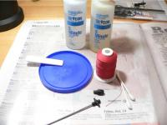
  Just like fly tying.
  54.9 KB - Views: 231
  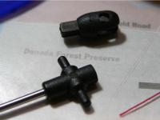
  Two pieces can be good.
  46.6 KB - Views: 229
  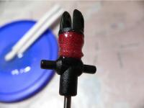
  All tied up now...
  37.8 KB - Views: 310
  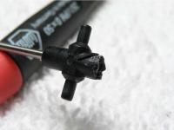
  Too little glue.
  36.3 KB - Views: 285
  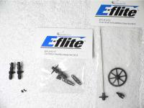
  Where are my screws?
  71.3 KB - Views: 239
  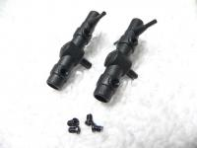
  Good hubs, bad pivots.
  35.5 KB - Views: 254
  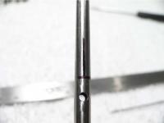
  Mark for alignment.
  28.5 KB - Views: 233
  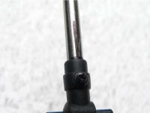
  29 mm from top of shaft.
  31.0 KB - Views: 223

LOWER ROTOR PIVOT BREAK
Lower Rotor Head and Linkage Set - rotor pivot breaks, $6.00
http://www.horizonhobby.com/Shop/By...ProdID=EFLH1217
This is the part I didn't know I had broken, because the BCX still flew ok. One of the two plastic pins that form the lower rotor pivots broke in one of my crashes. I didn't notice it until I was disassembling the BCX to remove the upper rotor hub. The pin sheared off at some point.
Note: If you've broken the upper rotor hub, check the lower rotor pivots, because you may have broken one, too. If the second one is cracked and breaks in flight, it could get nasty.

TOO SENSITIVE CONTROL
Flying out of the box I found the BCX very sensitive, too much for inside flying. I adjusted the flybar linkage 1 1/2 turns out (counter-clockwise). There’s a very big difference in flying. The machine calmed down and I could hover hands off for several seconds. Now it's a lot of fun flying in the garage. I could also fly outdoors in very light wind. A great little machine...

TAIL DRIFT
I tested my newly ventilated BCX last night, and I'm happy to report that it flew through 2 battery packs and my rudder trim didn't move a single click! That's right, dissipating that heat appears to have done the job. More flights will follow after work tonight, but I believe my drift problem has been solved.

The key to effective cooling is not so much the size of the holes, but instead the proportion of the OUT versus the IN. The OUT should be 2-3 times that of the IN. This is what creates good flow properties. IF you do not get the proportions right the air gets captured and pressurizes and heat, working against what your trying to accomplish. Hole square area in the 3/4" total combined of IN hole/s, would need 1 1/2" - 2 1/2" square area of exit OUT air. This principle application will be why so many varied results on the subject of what works and what works BETTER.........
Top of the 4-in-1 unit...
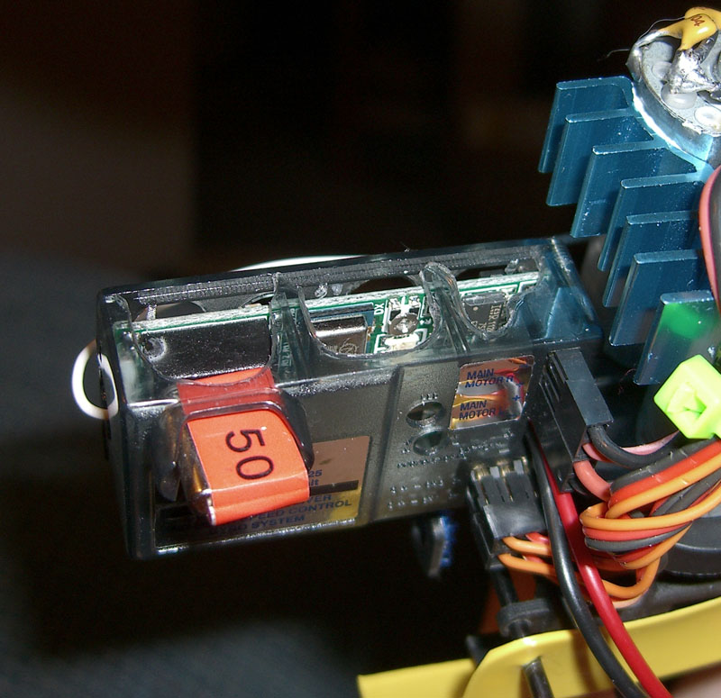 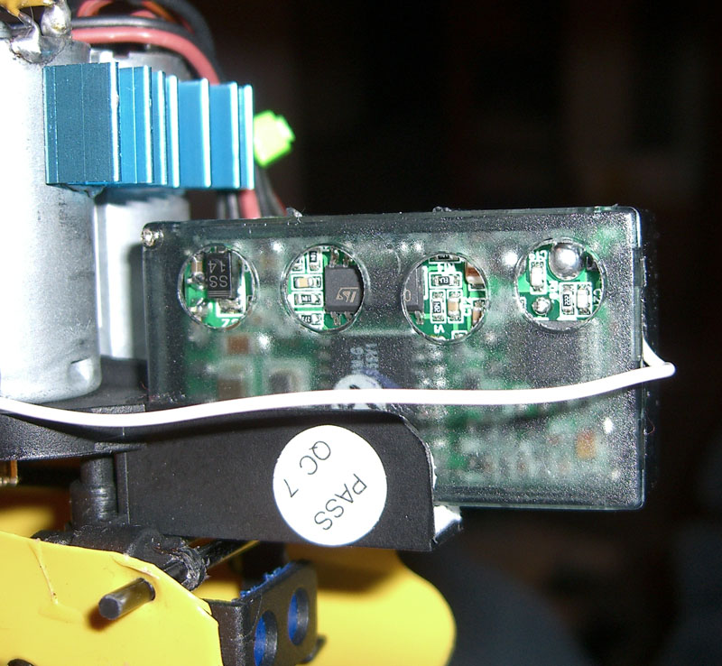

Or remove the case entirely
and affix with tie(s)
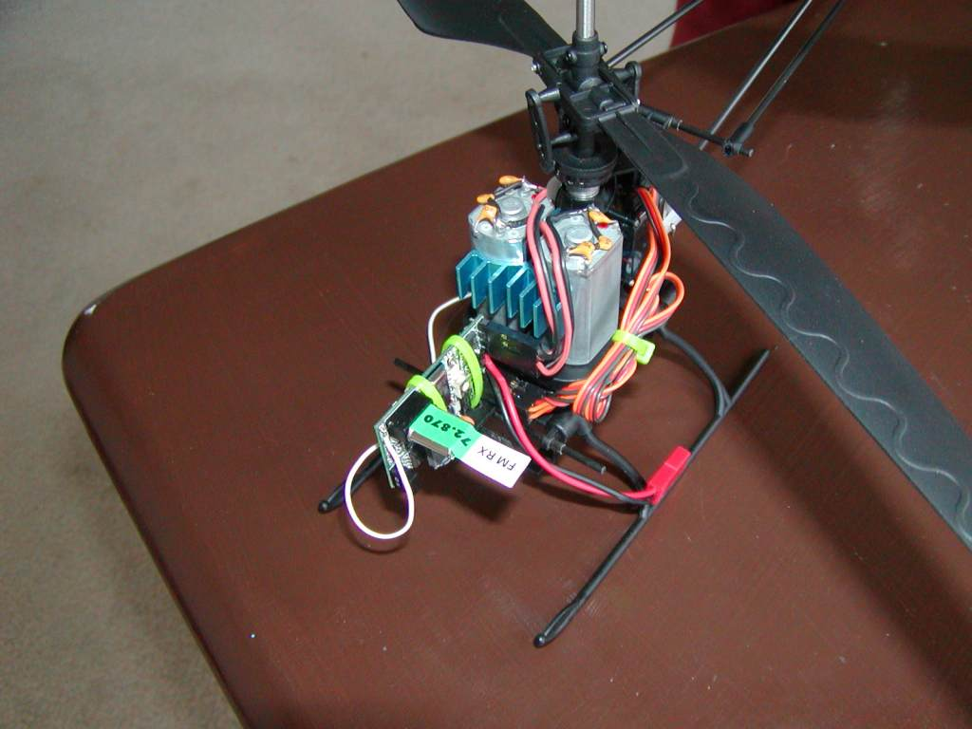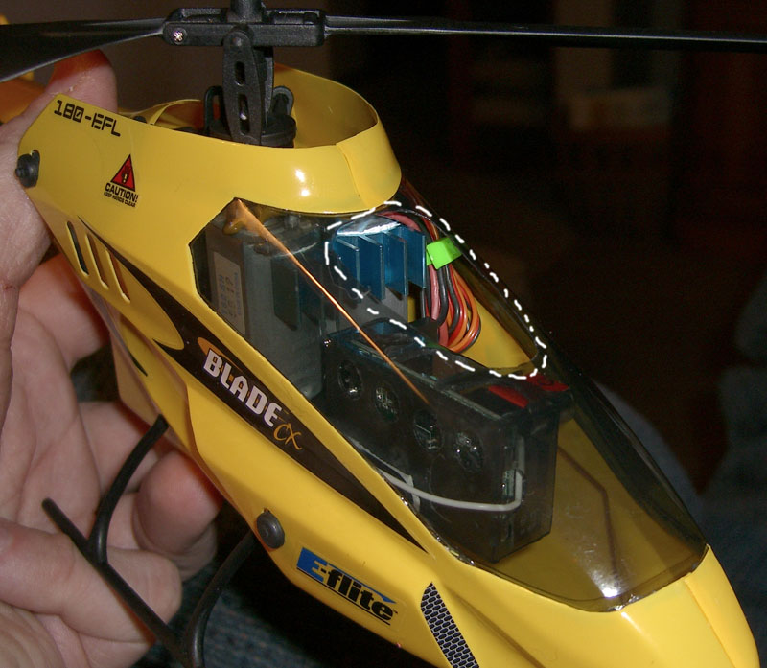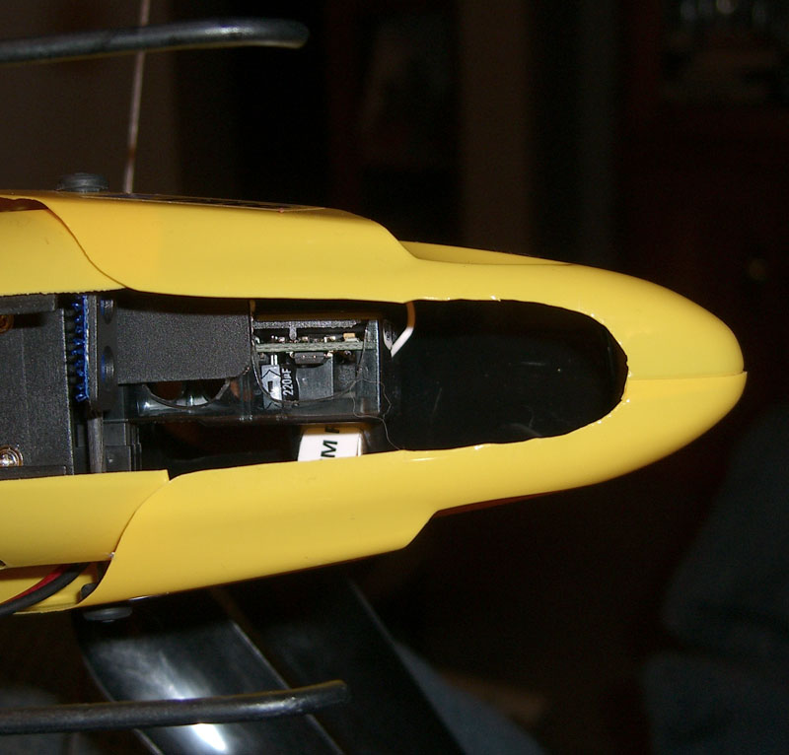

SCREEN FOR CANOPY
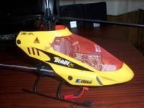

ANOTHER TAIL DRIFT SOLUTION
After about a minute into a battery, the nose of my BCX starts to drift left and gets progressively worse until I have use up all the rudder trim and am holding almost full right rudder to keep it straight. I, as other have, flew it with the front canopy off, and had no such problems indicating it is indeed a heat issue. I installed the heat sink and this had negligible if any effect (should still be good for motor life). I cut a hole in the windshield above and about the size of the 4 in 1 which provided some reduced rudder drift. You would think getting enough airflow would simulate having the canopy off, but its not enough.
My final fix is to power up and run the bird for a minute or two, then reboot by disconnecting and reconnecting the battery. Allowing the motors to come up to temperature and then rebooting the 4 in 1 seems to solve the problem entirely with the heat sink and improved airflow over the controller as it did not work very well without the other modifications.

ANOTHER TAIL DRIFT SOLUTION
Like most of you, I too have difficulty with the yaw to the right, particularly difficult for an untrained hand. Seeing the way the 4-in-1 acts on the throttle - reads the signal from the TX before the light goes on - I got a hunch that **MAYBE** the rudder/motor control is doing the same thing. That is, wherever the trim is at the point you arm the 4-in-1 it's assigning that as "center."
So the last 5 flights, I've turned on the TX, pushed the rudder/motor trim full right, then armed the 4-in-1. After arming, I've now got enough trim to get it to rotate to the LEFT! I've got enough room on the trim now to dial out the rotation completely.
I left the TX ON, moved the trim, and re-armed the 4-in-1, allowing it to use the full right position as "center." Again, total newbie here and just a hunch, but it appears to be working. I still have the 4-in-1 trim pot full counterclockwise, so my next experiments are to set that to center and try the same thing.

REMOVING THE 4IN1 CASE
I removed the 4in1 from its case last week. First mark then remove all wires from the 4 in 1 unit. Remove the unit from its base of the Blade. Remove the two small screws from the end of the case. Tilt the top up, from the screw end and remove. Now there is a small piece of double sided tape holding the circuit board inside the case, so very carefully pry up one end of the circuit board and then work yourself around the case till it pop's loose. It's really easier then this sounds. Then I used another piece of double sided tape to secure the circuit board back on the Blade's base as well as a tie. I also cut holes in my canopy with a Dremel tool with a cone shaped sanding block. It worked great.

THROTTLE STICK MOD
A simple and useful modification is to remove the notches from the throttle stick on the transmitter. This will give a much improved hover and vastly smoother take offs and landings. There are four screws holding the back of the transmitter on and unscrew the antenna. Once the back is separated you can unplug the power lead from the circuit board for ease of access. On the throttle stick you will see a small metal strip held in with a screw remove the screw and metal strip. There is a little hump formed into the strip that makes the notches you need to flatten the hump with a small hammer on a hard surface and then reinstall the strip and screw. We do this all the time with our glow choppers.

Yea, those detents can be a real pain on a heli. Another less permanent method is to simply flip the metal piece over. You'll no longer feel the notches, and the resistance can be adjusted by bending the steel a bit. You can also undo the mod if you intend to sell the Tx or use it with a fixed-wing.

I opened the Tx case, bent the throttle spring back slightly and slipped a piece of silicon tubing over the spring. No ratcheting and holds nicely.

.
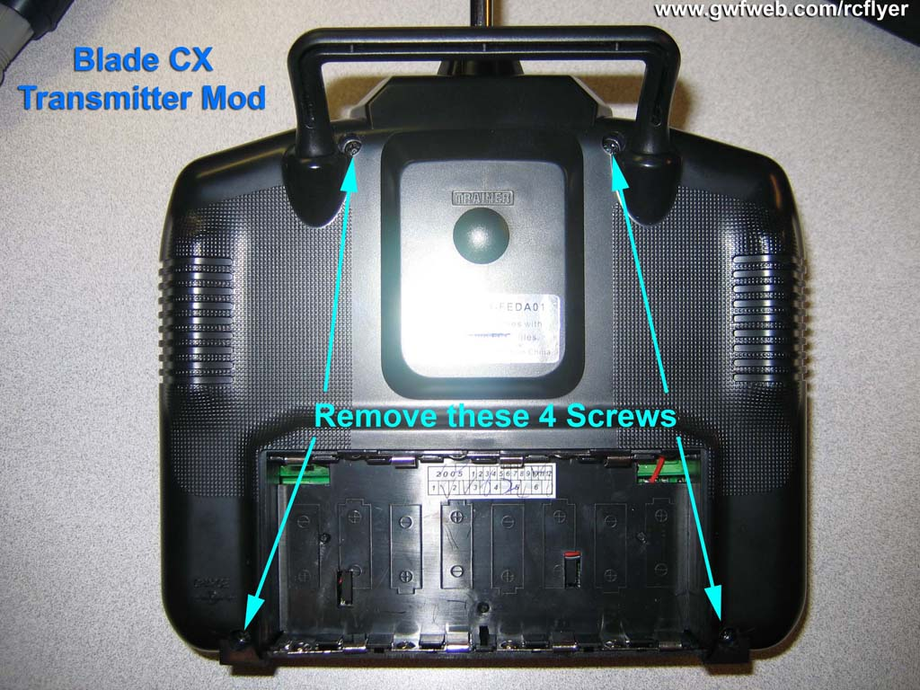 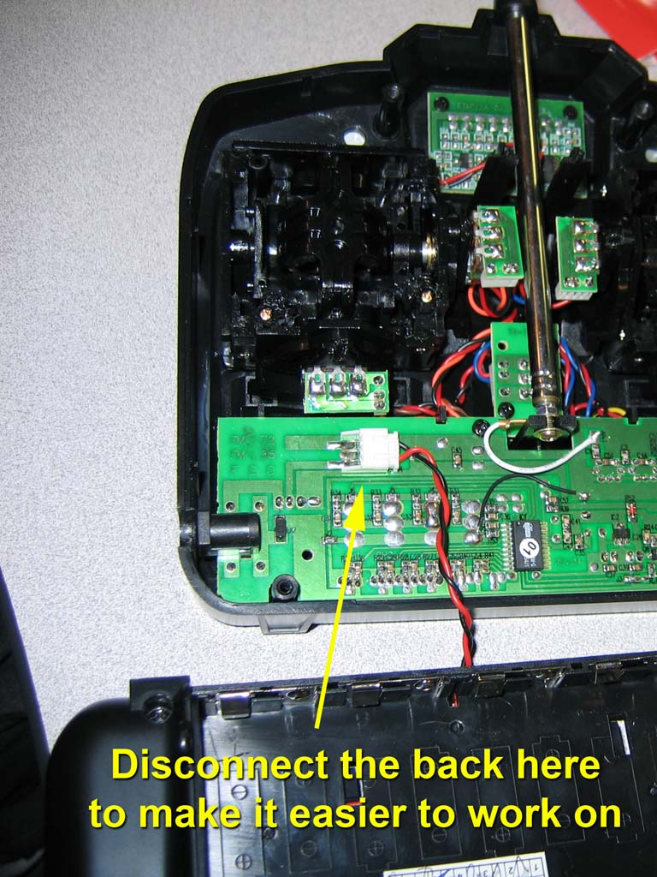

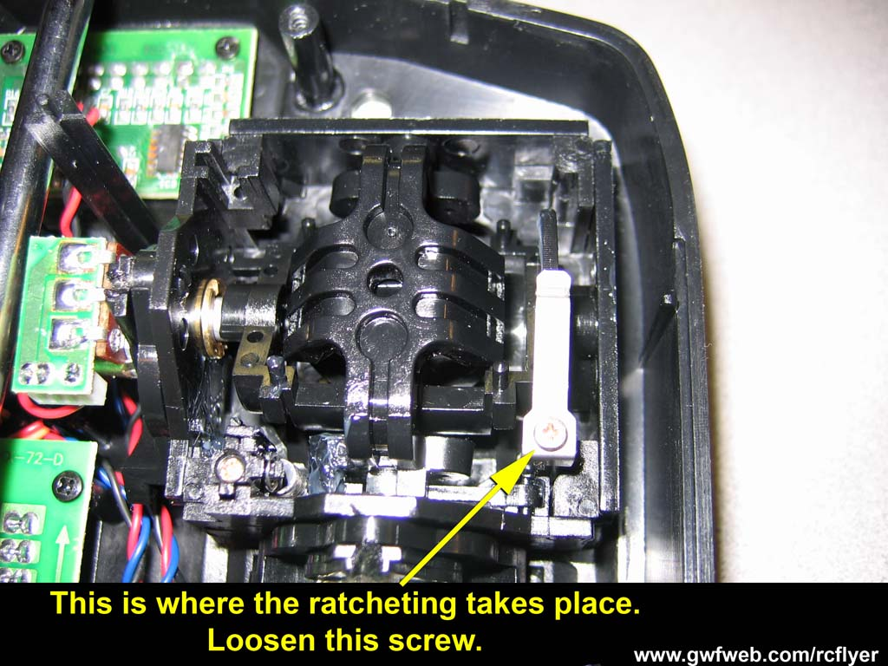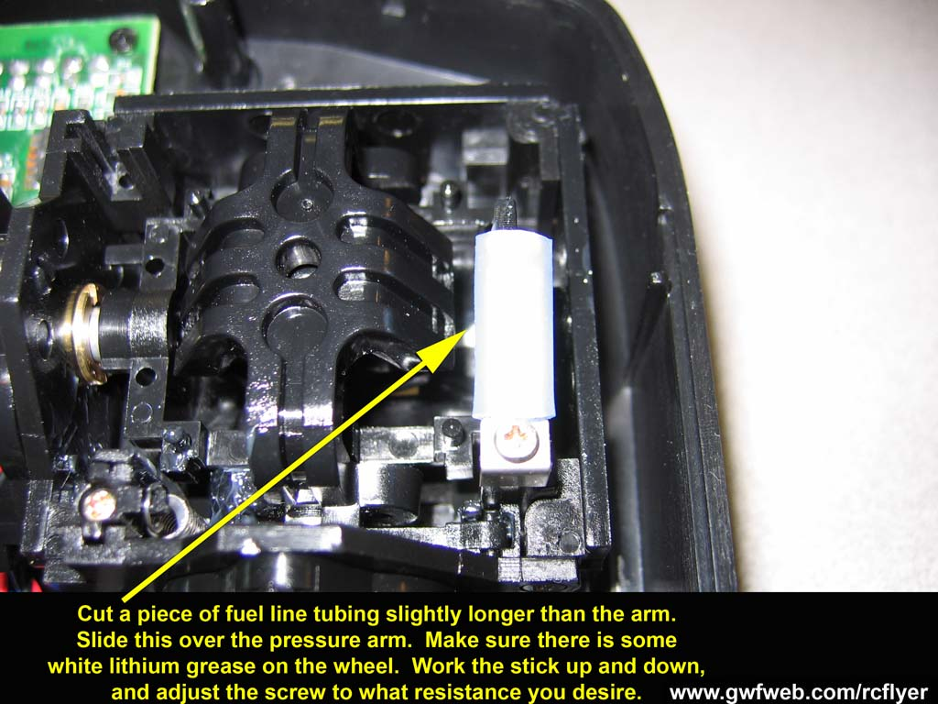

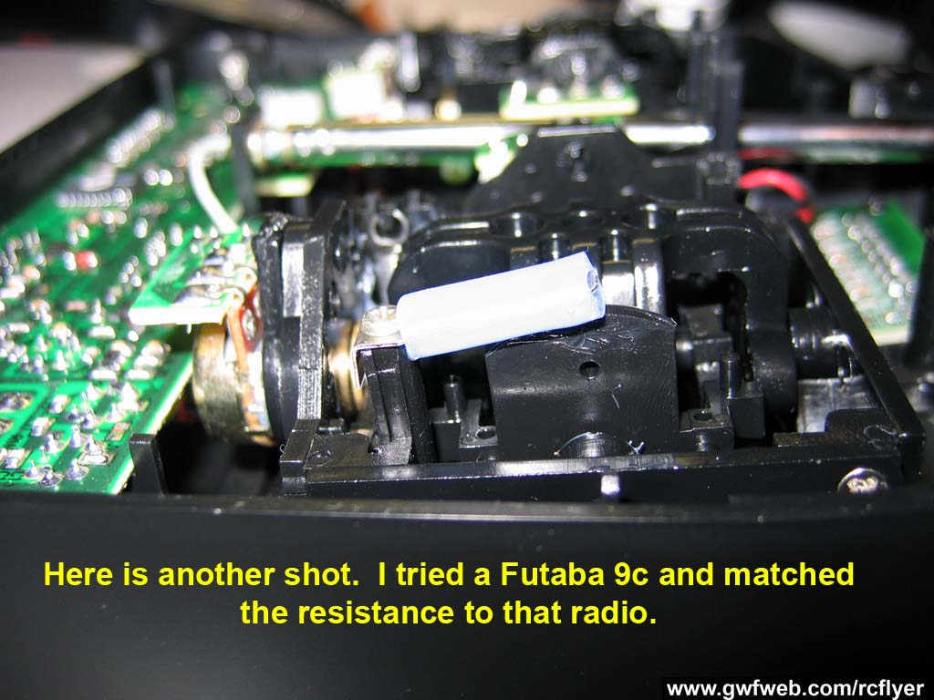

FLYING OUTSIDE
I just had another flight outside last night. There was barely any wind, not even enough to move leaves around or snow, yet I was struggling to keep my CX from shooting backwards while going into this very light breeze. I know its not a balance issue because I had just flown it inside my house. I’m wondering if it that I need to adjust the control arm position on the servo arm. Right now I’m set up for stock, would this help me out at all by giving me more control?
I just moved the servo control horn out one notch. This gave more penetration outside without too much sensitivity inside. Just keep the stick movement nice and gentle.
I've found on my Blade and Lama 2 that if I place add a little nose weight that it will penetrate better. On the Blade, I used a glob of clay about the size of a marble and mashed it into the nose (I used yellow clay so it doesn't show. I also usually add extra fwd. trim for outside. When I fly indoors, it has just a little fwd motion with this weight, and I can usually handle it with no problem.

VIBRATION AFTER A CRASH
Things to check:
- Flybar is straight, weights are in proper place.
- Upper blades track correctly, adjust if they aren't, and linkage to blade isn't cracked (The part that snap's on the blade ball)
- Lower blades track correctly (there are no adjustments for this) If they aren't tracking right it must be one of several things that could be wrong.
a. The lower rotor head has a cracked or broken blade support
b. Take out the screws holding the blades and make sure the plastic blades fit together tight (if they don't quite seat correctly, it can cause problems with upper and lower blades). Reset screws.
c. Pop the linkages loose from the blades and reverse them, i.e. left goes right, right goes left (I know it sounds crazy, but it has worked for me).
d. Replace the blades one at a time. Change one and fly, if it doesn't help replace another and fly. I've had a couple that after a mishap they appear fine but I have a vibration in them. Slightly bent plastic??? I don't know, but try it.

BALANCING BLADES
I recently modified my CX by replacing the rear fuselage with a CF boom tube and fin as so many others have done. On the first flight I experienced pretty severe vibration of the boom tube and fin which hadn't been previously noticeable with the more rigid stock rear fuselage. The flybar appeared to be in balance, so the vibration had to be coming from out-of-balance blades. Only problem is, HOW THE HECK DO I BALANCE 'EM?
Well, the system I used isn't perfect, but it worked a lot better than I thought it would. I simply took a SET of blades (upper or lower), weighed each blade individually on my POWDER SCALE, and set the scale to the LIGHT blade. I then carefully scraped material from the FULL LENGTH (very important) off the leading and trailing edges of the HEAVY blade (weighing frequently) with a sharp razor blade until it weighed the same as the light blade. I then sanded the edges of both blades with light sandpaper. This gets rid of any imperfections from scraping, and any flashing on the blade you didn't work on. Double check on the scale and scrape/sand to correct for any minor differences in weight and you're done. You should end up with 2 nice smooth blades that weigh exactly the same. Do the same with the other set and you're ready to go!!!
When I weighed my blades before balancing, I was surprised at how much difference there was in weight between blades, but it wasn't difficult to remove enough material from the heavy one to make them weigh the same. It is very important to use a powder scale or something with equivalent accuracy because of the light weight of these blades.
Before my balance job, my tail fin was just kind of a blur in flight. After the blade balance, there was absolutely NO sign of fin vibration at all.
You can use just the pair of blades as a balance , here’s a few pics

  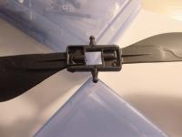
  39.1 KB - Views: 54
  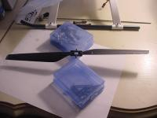
  38.8 KB - Views: 62

LEFT / RIGHT YAW SPEED
Out of the box my CX would yaw left way too fast and barely to the right.
Being delicate on the controls, it didn't really cause a problem.
After all the mods it is certainly better than stock but still didn’t have equal yaw until tonight. I cut the case to allow easy access to the gyro gain pot.
There is a sweet spot on the gyro gain and after about 15 readjustment and resetting it is on the money. The tail is still a bit twitchy in hover but flying is unequivocally better than it was out of the box.
Turning it all the way clockwise damn near turns the gyro off and makes it a handful allowing the tail to keep going after making a yaw correction in either direction.
Turning it all the way ccw definitely makes it over sensitive and affects the yaw speeds.
Since it is a square pot, I used a precision screwdriver the same width and one side of the square.
Start all the way left and use small increments until you have it adjusted properly. Leave the radio on and disconnect power to the heli before every adjustment.

SAVING THE 4 IN 1
When you get ready to fly your coax heli, do not use the throttle trim at all. Leave it in the down position, just use the throttle stick to fly.
You will have all the power you need to fly, and, in the event of a crash, you can shut the throttle off quickly. If the trim tab is left on the throttle won’t shut off completely risking burn up your 4in1.

REPAIRING THE LOWER BLADE PINS
Seeing that BCX parts are starting to become scares I decided to repair 2 of my lower hubs that had the blade pin(s) broken off.
I used a # 38 drill bit because it most closely matched the diameter of the pins. (.100”)
I also used a drill press to get my holes nice and perpendicular to the hub surface.
After drilling the holes I used a Dremel tool (with a cutoff disk) to cut the pins right from the drill bits shank to the proper length. I then finished the edges and CA-ed them in place.
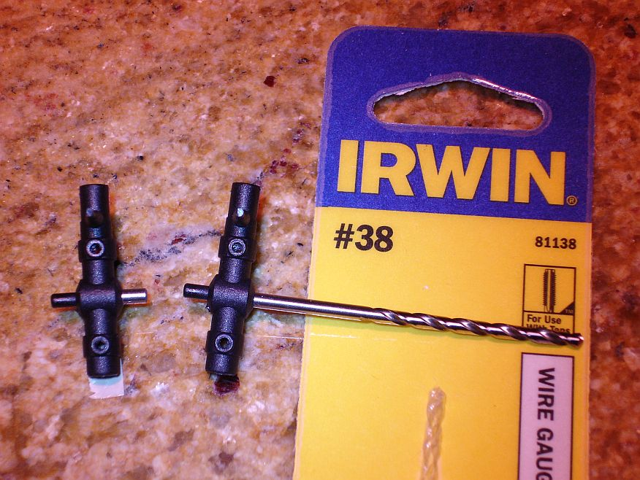

ANOTHER FIX FOR LOWER BLADE PINS
This is an easy fix for any of the many people here that have snapped the blade pivots off the lower rotor head.
Remove the lower rotor head piece from the heli and drill a 5/64 hole through the part were the blade holder stalks used to be.
Cut 2 pieces of 5/64 linkage wire approximately 3/8 long. I cut the pieces off a broken inner shaft instead of linkage wire. Slide the lower rotor head back on and insert the wire into the holes. Use a small drop of thin CA at the base of the wire. Remove from outer shaft and let dry before re-installing.

TOILET BOWL EFFECT
The top hub had worked itself up a TINY amount, 64th of an inch maybe. I pushed it back down and the problem went away. I've seen a few posts of others having this problem, and there's a lot of discussion about it being the flybar sticking.

INSTALLING THE MOTOR HEATSINK
I was able to remove the right main motor without taking the outer shaft off.
1) remove inner shaft/gear
2) remove the motor screw not blocked by the gear
3) carefully use the screw driver to loosen the screw partially hidden by the gear. You will need to cockeye the screwdriver slightly. As you turn the screw move the motor out so instead of the screw backing out toward the gear, the motor backs away from the other side.
4) reverse the order to put them back the same way

CORRECT FLYBAR ORIENTATION
Wrong Way Right Way
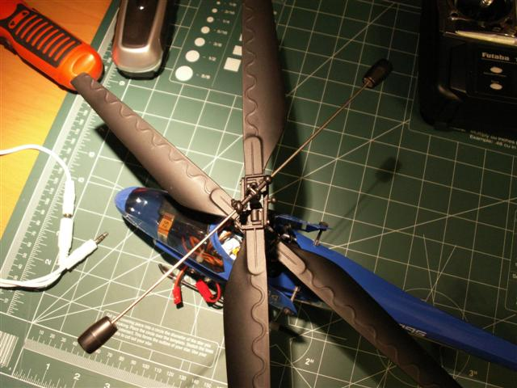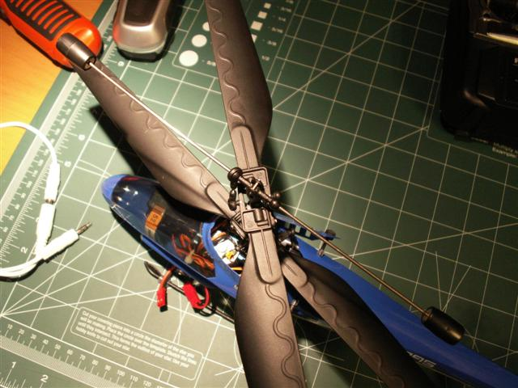

CX STOCK BATTERY PACK CHARGING
As you may have seen in some of the other threads, flight durations of 10-12 minutes (or even up to 15 minutes) should be more typical when using the stock battery. Here’re some things to check:
If you have a DVM, carefully check voltage of the individual cells in the pack for balance. Check using the red and blue wire first, then the black and blue wire. If the cells are within 0.03v, the problem may indeed be related to something else...
Also, be sure to check your pack and individual cell voltage after the charger indicates the pack has been fully charged (Red Solid LED only). The cells should be within 0.01-0.03v and the pack should be between 8.3 and 8.4v...if the pack is below 8.3v, you are not getting a full charge.
For individual cells:
4.2V – 100%
4.1V – 87%
4.0V – 75%
3.9V – 55%
3.8V – 30%
3.5V – 0%
The 0% @ 3.5V is not really accurate for our packs but it's pretty close. Below 3.5V, there's very little capacity left. At that point, my CX won't climb or hover out of ground effect although it would probably stay up in ground effect another 15-30 seconds. IMHO, that's as bad an idea as discharging a LiPo too far (<~3.0V) which can damage it's capacity or ruin it outright. It can even induce an internal short that can lead it to leak, go on fire or even explode when recharged.

LED LIGHT KITS
http://www.tjtrc.com/
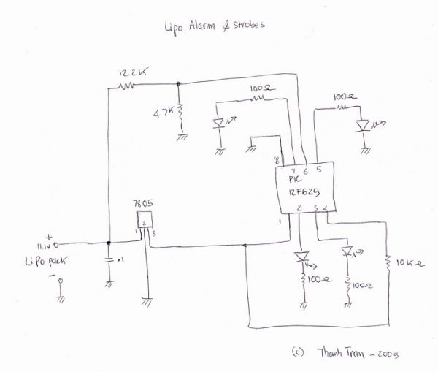
http://www.superbrightleds.com/hobby.htm

TRIMMING THE BLADE CX
Problem: I have the Elevator Trim at its highest point, the Aileron Trim the farthest to the left and I still have to hold the elevator/aileron stick all the way in the upper left hand corner to even come close to a reasonable hover while off the ground...of course this means I can't move the thing forward so I am constantly using the rudder stick to spin the heli so when it drifts very slowly backwards it gets to where I want it to be...
What’s the next step to get this damn thing all set to fly as normal as possible? And yes the battery is pushed in far enough, and I am using the same sets of rotors (matched the numbers) and there is no vibrating or shaking coming from the heli.
Solution: One way to go about it is to turn it on and hold the sticks like you would in stable hover only with no throttle so you can get a good eyeball on the position of the swash plate , then center your trims , and turn it all off and pop the links off the swash , and if you look you will see the plastic ends are threaded on so you can adjust the length of them to get the swash to sit in as close to the hover position as you can get , try hovering again and note where you have to hold the sticks for stabile hover , by repeating this you should be able to get it to hover hands off with both trims centered.
Results:
I did it...and it is amazing results...however, I don't think I'll ever be able to get it to hover with the trims in the center because I almost had to unscrew one link completely off the metal rod...but it is so much more responsive now and I am absolutely in love with this thing...thank you!

USING THE TRANSMITTER TRIM
Problem: Even with the trim all the way forward I'm drifting back.
Solution: Move the trim tab on the TX all the way forward before arming the CX and then center the trim tab before flying. The servo will center with the trim tab all the way forward and it will give you a lot more room to trim when you start flying. I have done that and it works great.

AILERON TRIM
If your aileron trim is all the way to the left what you need to do is adjust the linkage... its pretty easy on this heli first off, remove the front body section, now, look at the linkage in the picture below, that's the aileron linkage, now mentally remember where its at, pop off the linkage, then center the servo trim and turn the top part of the linkage until it looks like its at about the same spot it was at before... then test fly it, repeat as necessary.....
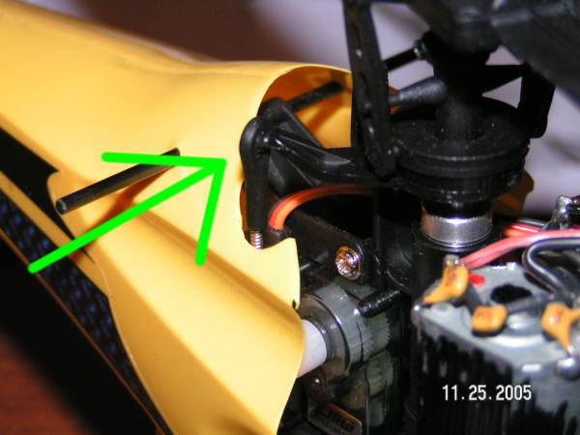

SWASHPLATE TRIM
I like many others have crashed and repaired things. Even though nothing looks wrong something may have slipped. Case in point, the image below. I had to have full up & left trim to keep my heli hovering, but even this wasn't enough as I still had to hold a little up and left to keep it still. Coming from airplanes, I was going to reset my trims and move the control arm, but when I looked at the whole (blade assembly moving parts thingy?) I noticed that it wasn't parallel with the collar below it. (is it supposed to be parallel?) instead, it was raised and more in line with the redline. So I loosened 4 screws (where the fingers are pointing) and moved the entire assembly down until it was parallel. NOW MY TRIMS ARE BACK TO THE MIDDLE! I went through and leveled a bunch more stuff and tightened everything, seems to fly better, and even make less noise!
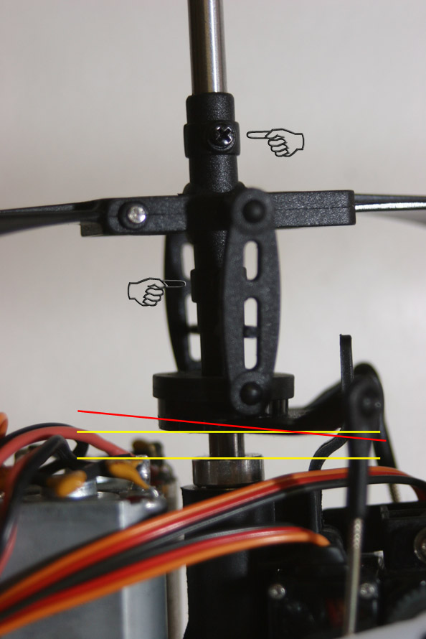

CHECKING FOR BENT SHAFTS
If your problem is more like a massive vibration, first remove the blades and flybar and remove one motor plug from the esc and slowly apply throttle (no more than about half throttle, max) and watch whatever shaft is spinning while holding the heli in your hand. You should feel no significant vibration or see any wobbling. Then remove that motor plug and plug the other one back in its slot and do the same. If no wobbling or vibration, then it is your blades or flybar that need a tune-up or replacement...

NOSE IN FLYING
Here is a trick that may help with "nose in"
”:PROP IT UP”
As you look at the heli with the nose toward you just move the right stick to "PROP UP" whatever way the heli is moving....
If it is moving toward you that means the rotor disk is tilted toward you so "prop it up" ..... if it is moving toward your left the rotor disk is tilted toward your left so "prop it up".
After awhile it will become instinct.

TAIL MODS
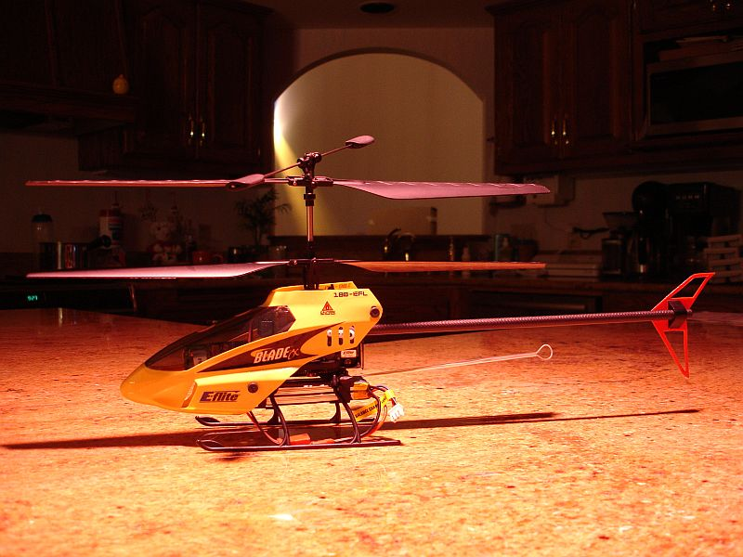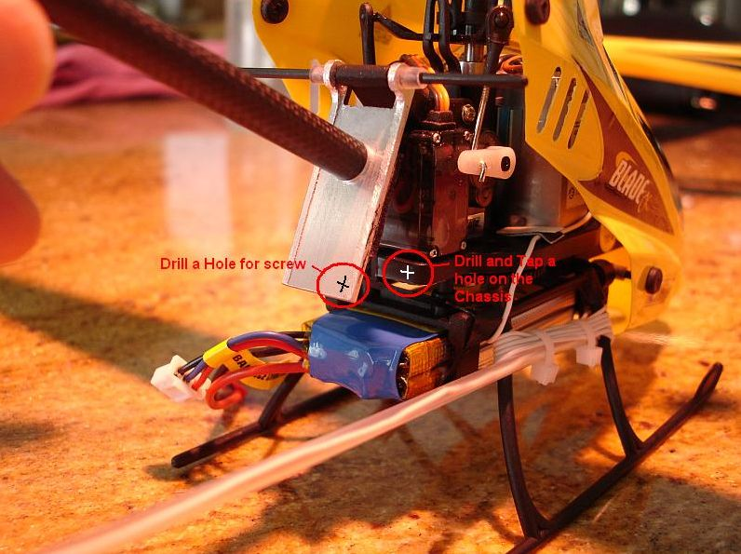

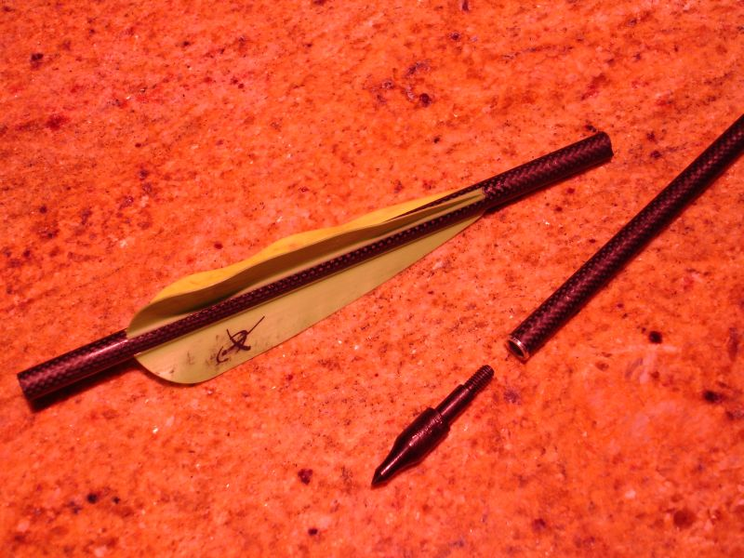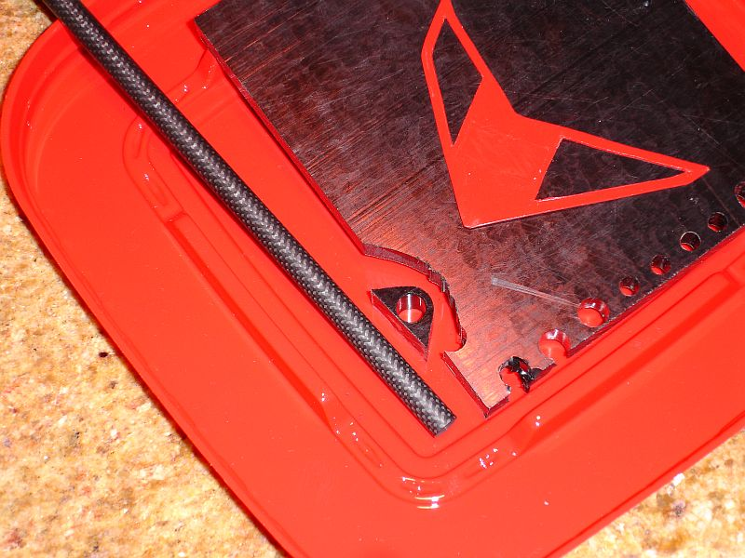

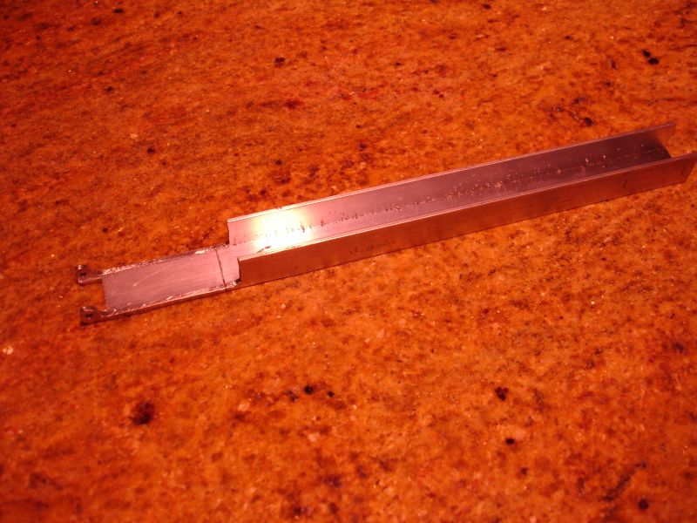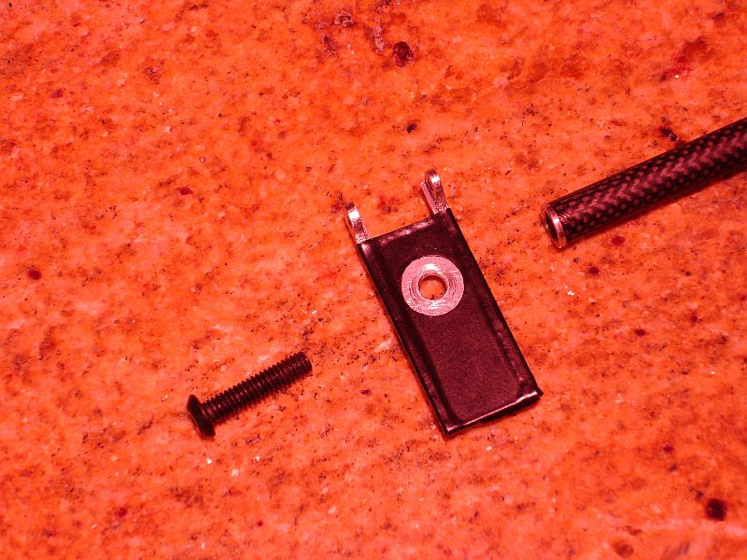

Tail boom 9 ¾” long…
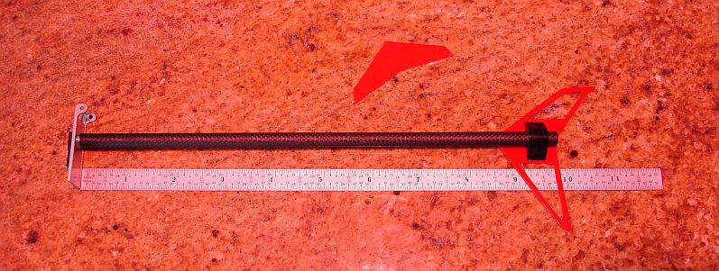

HELI CAM
http://www.helidirect.com/product_info.php?cPath=72&products_id=795

LIPO ALARM
http://www.rcgroups.com/forums/showthread.php?t=221018
http://bladecprepair.com/smf/index.php?topic=40.0
Here are the RS components part numbers for all the parts used -
U1 283-845 TL431CLP
Q1 296-043 2N7000
R1 148-635 3.6k 1% resistor
R2 422-1835 2.5k 1% resistor
R3 422-1778 1.5k 1% resistor
X1 228-1627 5 volt piezo alarm
The value of R1 to set the alarm trip level, and R4 to drop voltage so X1 doesn't see more than 7 volts maximum. The voltage developed by the R1/R2 divider that connects to the "Reference" pin of the TL431 wants to be 2.5 volts when the battery is at its warning point (that would be 3 volts per cell used). Select R1 to drop the appropriate voltage using Ohm's law. The piezo I picked has a maximum voltage of 7 volts, so a dropping resistor is needed as the battery voltage goes above 2 cells. I used the specs on the piezo as a starting point, but then trimmed the resistor via testing.
Shifting the R2 value up will cause the alarm to sound at a higher battery voltage, shifting the value down will cause it to sound at a low battery voltage. The nominal trip voltage for a 2 cell unit is 6.00 volts. If you use a 2.6K resistor at R2 then the alarm will sound at about 6.2 volts.
